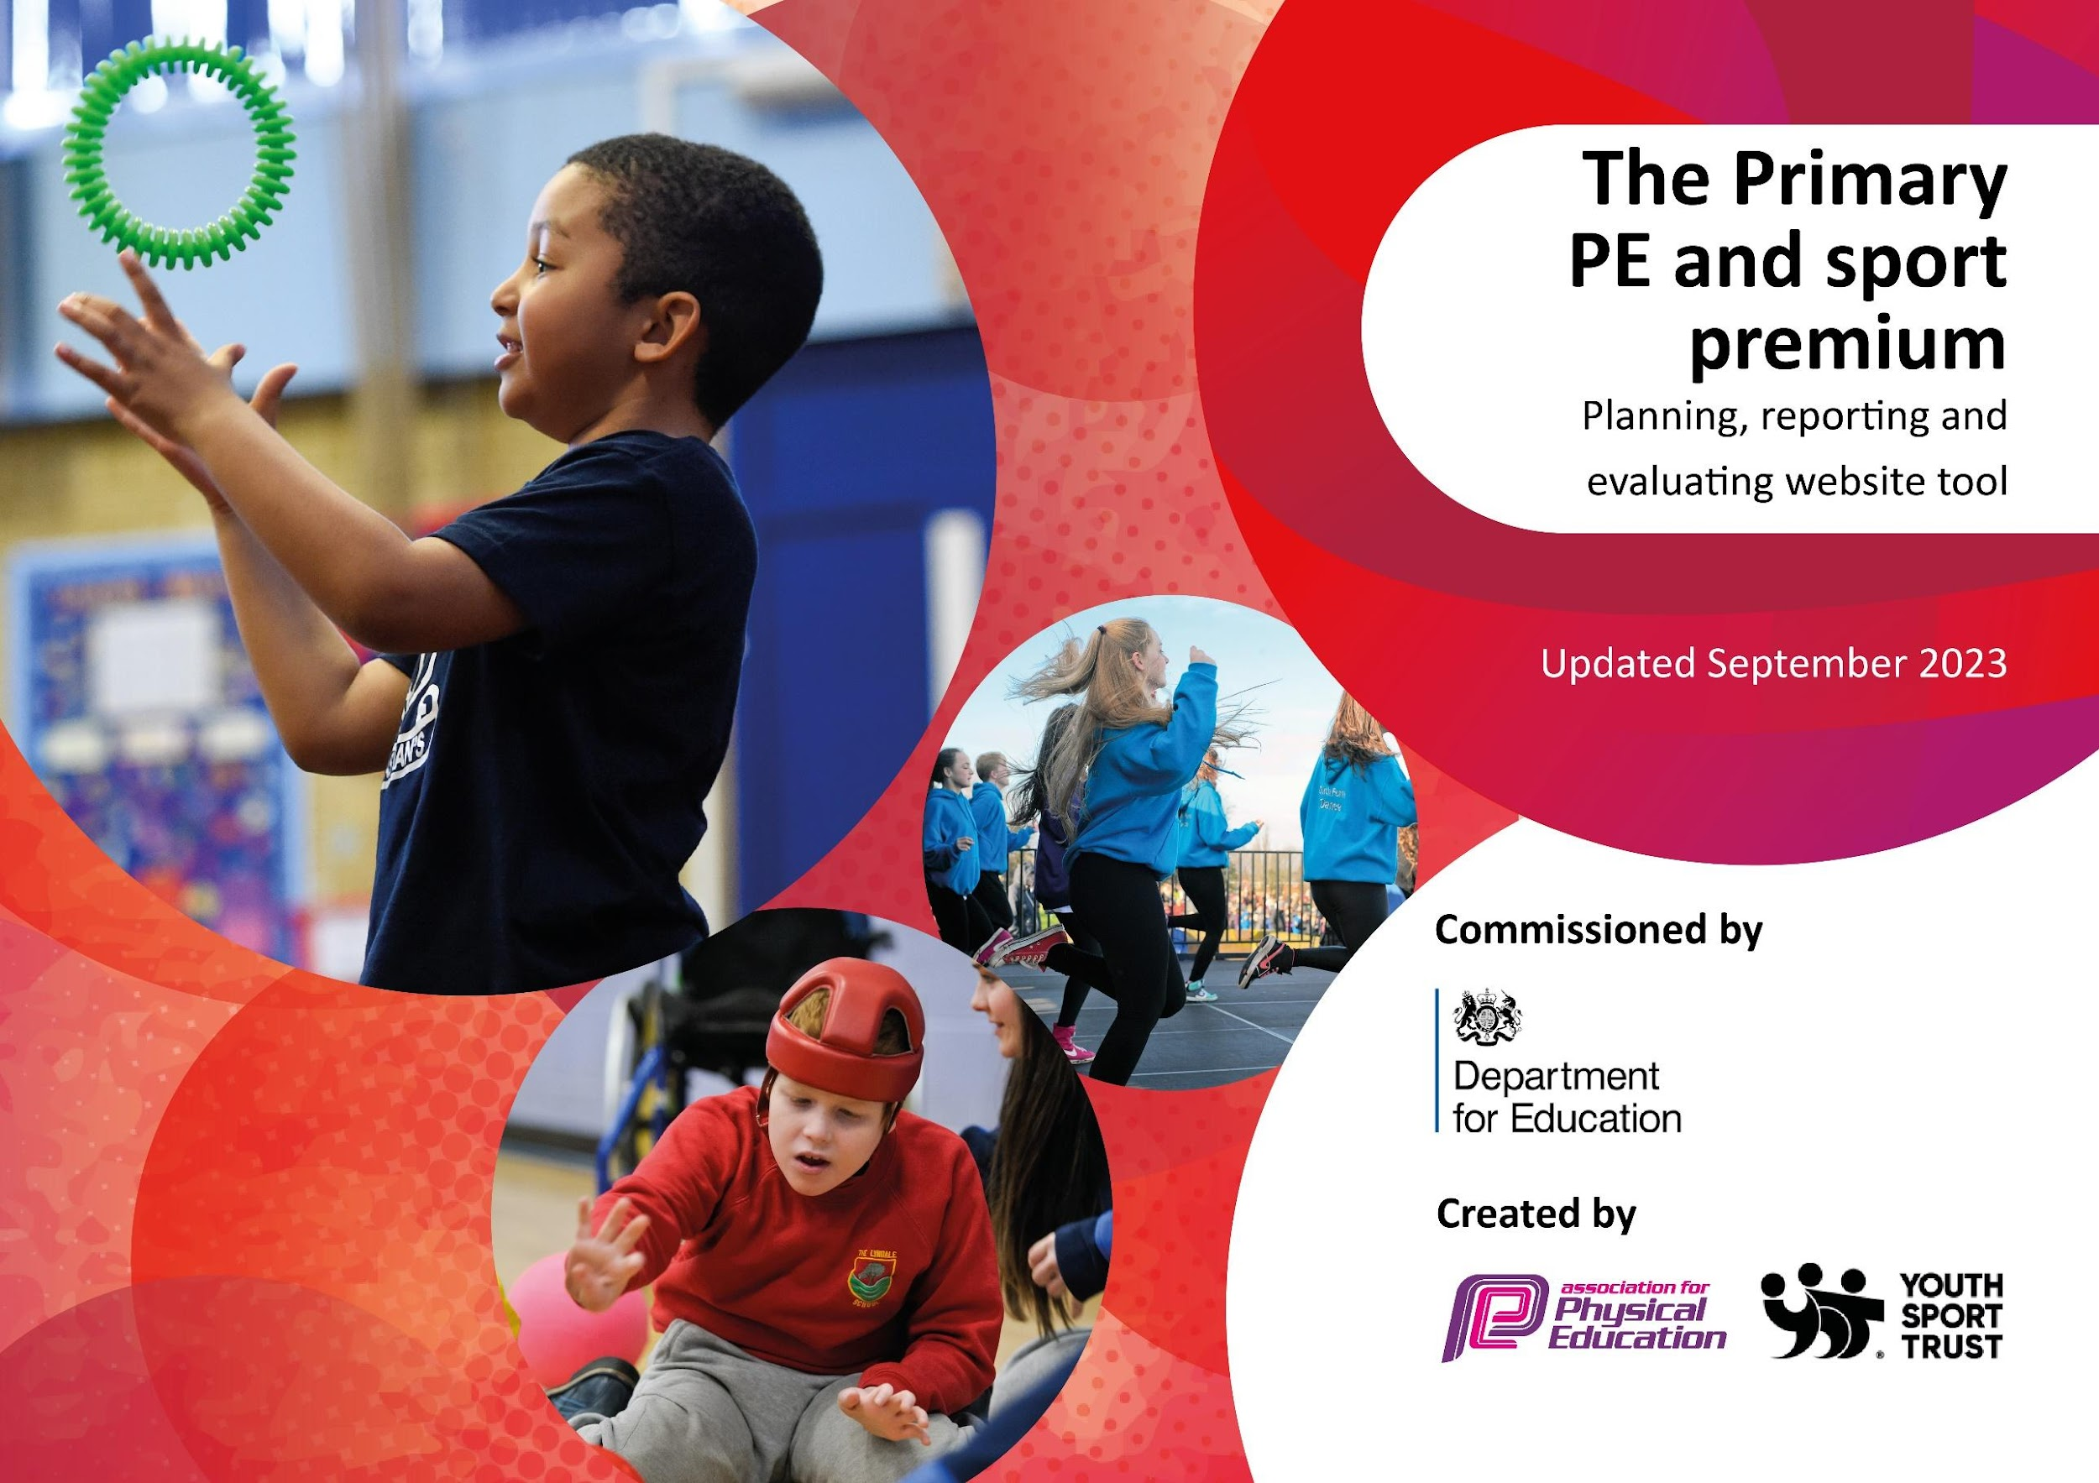

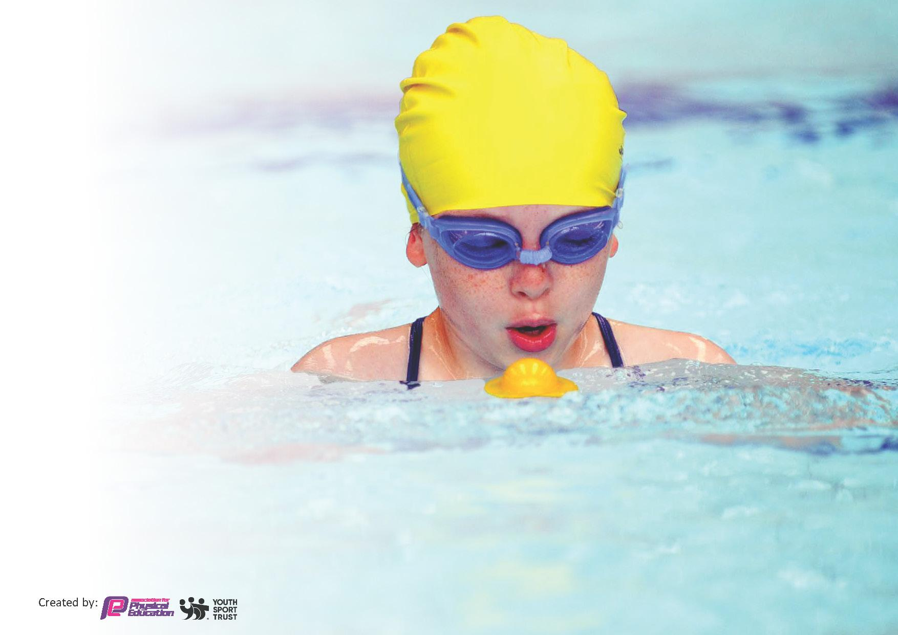
This template can be used for multiple purposes:
by:
- It enables schools to effectively plan their use of the Primary PE and sport premium
- It helps schools to meet the requirements (as set out in guidance) to publish information on their Primary PE and sport premium
- It will be an effective document to support Ofsted inspections enabling schools to evidence progress in Physical Education (PE) and evidence swimming attainment, which forms part of the PE National Curriculum. We would recommend schools consider
the Intent, Implementation and Impact of any spend, as examined within the Education Inspection Framework.

It is important that your grant is used effectively and based on school need.

Schools must use the funding to make additional and sustainable
improvements to the quality of the PE, School Sport and Physical Activity (PESSPA)
they offer. This means that you should use the Primary PE and sport premium to:

- Build capacity and capability within the school to ensure that improvements made now will benefit pupils joining the school in future years
- Develop or add to the PESSPA activities that your school already offers.

The Primary PE and sport premium should not be used to fund capital spend projects; the school’s core budget should fund these. Further detail on capital expenditure can be found in the updated Primary PE and sport premium guidance.

The Primary PE and sport premium guidance, outlines 5 key priorities that funding should be used towards. It is not
necessary that spending has to meet all the key priorities, you should select the priorities that you aim to use any funding towards.

Although completing this template is not a requirement for schools, schools are required to publish details of how they spend this funding. Schools must also outline what the impact this funding has had on pupils’ PE and sport participation and attainment and how any spending will be sustainable in the future. All funding must be spent by 31st July 2024.

The Department for Education has worked closely with the Association for Physical Education (afPE) and the Youth Sport Trust (YST) to develop this template and encourages schools to use it. This template is an effective way of meeting the reporting requirements of the Primary PE and sport premium.
Review of last year’s spend and key achievements (2022/2023)

We recommend you start by reflecting on the impact of current provision and reviewing your previous spend.

Activity/Action | Impact | Comments
Continued subscription to GetSet4PE scheme of work.  Access to schools competitions (Schools games membership and competitions in the local felixstowe area/staff cover/transport)  Provision of extra curricular clubs  Invest in Moki fitness trackers | This is a great and easy to follow scheme of work for all members of staff to access. It also offers great assessment tools to aid the tracking of pupils progress.  Pupils are given the opportunity to represent our school in a variety of competitions.  Due to the cost of living at this time it becomes more difficult for parents to be able to access extra curricular club so to keep costs down we try to support our families best we can.  Help increase and encourage the amount of physical activity with the school day. | This scheme of work is now used in all areas of PE at Felix Primary school.  We will continue to offer as many opportunities as possible to allow our children to take part in competitive and non competitive activities as possible.  We offer a range of different sports club to pupils  R-Y6

Key priorities and Planning
This planning template will allow schools to accurately plan their spending.

Action – what are you planning to do | Who does this action impact? | Key indicator to meet | Impacts and how sustainability will be achieved? | Cost linked to the action
- Raise the amount of time for physical activity to 60 minutes per day per child  -Daily mile - reintroduce the daily mile across all year groups  -clubs  -enrichment | - All children as they will take part and it raises their physical activity  - Teachers and TA’s as they will lead the initiative in their class | The engagement of all pupils in regular physical activity  Broader experience of a range of sports and activities offered to all pupils | Higher percentage of children accessing 60 minutes per day of physical activity. | £1,200  £1000
- 2. To enhance PE throughout the school curriculum, Enrichment and extra curricular activities:  - after school sports clubs  - enrichment termly to include sports  - enrichment week in Summer term to include sports  - National organisations, clubs to provide taster sessions  - sports fitness days  - sports coaching  - resources | - Children taking part.  - Community support for clubs and activities. | The engagement of all pupils in regular physical activity.  Broader experience of a range of sports and activities offered to all pupils  Increased participation in competitive sport | Higher percentage of children accessing extra curricular PE, including clubs and competitions. | £7000
3. Raise the profile of sport in the school and community  -assembly celebrations  -visitors and enrichment  -inter and intra competitions  -visits from sports personalities  - Transport | - Children in the school  - Community support and visitors | The profile of PE and sport is raised across the school as a tool for whole-school improvement  Broader experience of a range of sports and activities offered to all pupils | Children's engagement and achievement in PE is celebrated.  Children and adults inspire others to take part and have aspirations in PE/Sport. | £100 (Trophies/medals/certificates)  £2000 (Transport)
4. To support the development of PE continued professional development to ensure access to high quality PE lessons for all:  -membership for SSP  -attend CPD provided by the SSP  -membership package  -internal teachers working with staff for CPD  -dance development in the curriculum  -audit, review and repair of resources  -shallow water training  -supply costs | - Teachers including ECTs  - Sports Premium lead | Increased confidence, knowledge and skills of all staff in teaching PE and sport. | Allowing teachers the opportunity for CPD.  Better resources for the children to be used during lessons and at break and lunchtimes. | £2500
5. To extend PE provision for targeted groups including SEND and PP  - Sports coach half a day a week  - After school clubs  - lunchtime provision  - Inter and intra school competitions.  - CPD for SU’s | - Children who take part  - Specialist Units | Increased confidence, knowledge and skills of all staff in teaching PE and sport  The engagement of all pupils in regular physical activity  Broader experience of a range of sports and activities offered to all pupils  Increased participation in competitive sport | PE to support the physical development of all children in the school; being open and accessible to all. | £2500

Key achievements 2023-2024
This template will be completed at the end of the academic year and will showcase the key achievements schools have made with their Primary PE and sport premium spending.

Activity/Action | Impact | Comments
Wider access to competition  Clubs  Increasing the schools daily physical activity | We have had a greater number and range of pupils have access to competitive activities this year where they have been able to represent our school. This include KS1, KS2 and SEND  We have continued to offer a range of KS1 and KS2 extra curricular clubs. Enabling a range of pupils of different abilities to attend and have access to extra provision.  We have purchased the Moki fitness trackers and are currently in the process of setting up groups and classes. | We will continue to provide as many opportunities as possible for as many pupils as possible.  We will continue to review and provide these extra curricular opportunities and aim to add to our current provision.  Four KS2 classes will be equipped with the new fitness trackers to enable us to record every pupils movement/daily exercise and if need be how to increase it.

Swimming Data
Meeting National Curriculum requirements for swimming and water safety.
Priority should always be given to ensuring that pupils can perform safe self-rescue even if they do not fully meet the first two requirements of the National Curriculum programme of study

Question | Stats: | Further context  Relative to local challenges
What percentage of your current Year 6 cohort can swim competently, confidently and proficiently over a distance of at least 25 metres? | 82% - 22/23 | Challenges to continue to address that all families are aware of the importance of water safety and are supportive of their child receiving regular swimming instruction to build not only skills but also water confidence.
What percentage of your current Year 6 cohort can use a range of strokes effectively [for example, front crawl, backstroke, and breaststroke]? | 24% - 22/23 | Our focus this year is on ensuring as many pupils as possible were able to swim the minimal required distance.

What percentage of your current Year 6 cohort are able to perform safe self-rescue in different water-based situations? | 52% - 22/23 | Additional support is given to the pupils at the pool during drowning prevention week to further educate them on the importance of being safe around water.
If your schools swimming data is below national expectation, you can choose to use the Primary PE and sport premium to provide additional top-up sessions for those pupils that did not meet National Curriculum  requirements after the completion of core lessons. Have you done this? | Yes/No | We currently swim the children all year round and feel that this is a sufficient amount.
Have you provided CPD to improve the knowledge and confidence of staff to be able to teach swimming and water safety? | Yes/No

Signed off by:

Head Teacher: | Jess Hearn
Subject Leader or the individual responsible for the Primary PE and sport premium: | Jack Entwistle
Trustee:
Date: | Autumn term 2023

