**Welcome to summer term’s learning for Pine class.**

This tells you what your child will be learning this term in school. We really value your support and the help that you can give your child with their learning. If you would like a detailed overview of curriculum coverage, please see our website [Felix Primary School](https://www.felixprimaryschool.org/)

**Literacy**

In English this term, we are focusing on sentence structure; what is contained in a sentence and the rules of a simple, compound and complex sentence. We will draw on new vocabulary and grammatical constructions from reading a range of books and listening to an adult read, which they will then use these in their writing. We will continue to focus on our presentation skills, ensuring that the date is written legibly and underlined in most of our pieces of work. More details on different types of sentences can be found here: [Simple, compound and complex sentences | TheSchoolRun](https://www.theschoolrun.com/what-are-simple-compound-and-complex-sentences-glossary)

Free Book Clipart, Transparent Book Images and Book png Files

**Communication and Language**This term, we will be using a variety of ways in communicating with each other. Communication is a vital skill needed in life; therefore, it is embedded in all of our lessons. Expanding the children's vocabulary is paramount to building their knowledge of language. Subject specific vocabulary is being taught alongside visuals and Makaton (if appropriate).

**Understanding the world**

In the wider world, we are learning about the United Kingdom, how the different terrains contribute to our landscape and comparing it to our local area of Felixstowe.  We will be using our map skills to identify capital cities, towns that recognise, rivers and seas and the similarities and differences between the country's cultures. In addition, we will continue to prepare our garden, by planting more seeds and hopefully making observations of the different plants that have been sowed.

Science Clipart Transparent Pictures – Clipartix

Image result for clipart geography

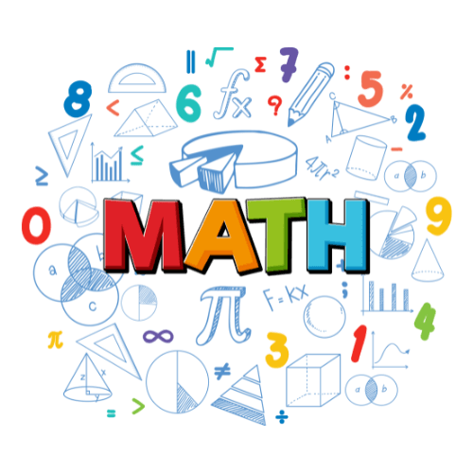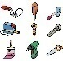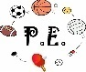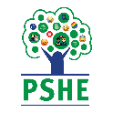

**Personal, social and emotional development**

We are constantly challenging the children to develop their PSE skills throughout the day and hope you will agree that for your children this is a vital part of their development.

During our 'morning meetings' the children will spend time recognising photos of each other, singing hello and all having a go at saying hello to the group. We will use visuals to say if we are happy, sad or angry and the children will begin to act each emotion. At lunch and snack the children will be encouraged to wash their hands with increasing independence and use their PECS books or talkpads to ask for help with opening packets etc. Children who change for PE or toileting etc, will be encouraged to become independent and celebrated for being independent, even if this means they have clothes on inside out or back to front!

**Maths**

In Mathematics, we are continuing to work on our number topic; focusing on our vocabulary in addition and subtraction- the two fundamental signs of operation, using a range of methods and concrete resources to support their learning. Ensuring that these concepts have been embedded, recapped, and revised before we move on to anything else in number. Engaging parents/carers in their child’s mathematical learning is so important at home because number is everywhere. A fantastic resource to support yourselves in the world of maths can be clicked here: [National Numeracy - Charity Empowering the UK with Numbers](https://www.nationalnumeracy.org.uk/)

**Expressive arts and design**

The children will continue to attend singing assembly which they have thoroughly enjoyed in the previous term- the children love to sing-along to current songs and learning new songs. In Art, we will continue to look at the skill of sketching, fine tuning the hold of a pencil and working on shading. Again, children love to express themselves through art, so plenty of opportunities to do art in cross-curricular activities.

**Physical development**

In PE, Miss Hart is teaching gymnastics and Mr Entwistle will support their development of gross motor skills in a variety of ways. . Pupils will develop balancing, rolling and jumping. They will develop their sequence work, collaborating with others to use matching actions and shapes. This will support their development of confidence to perform in front of their peers and within themselves. Attached is a 5-minute challenge for you to complete with your child at home to support their physical and emotional wellbeing. [Get Set 4 PE - Resource Bank](https://pe.getset4education.co.uk/ResourceBank/ResourceCategory/1175)

**Languages**

**PSHE**

**HOUSE KEEPING**

* A reminder that we do PE on a Monday and Tuesday-the expectation is that your child brings in their PE kits on a Monday morning and take them home on a Friday afternoon.
* If there are concerns or queries, please do not hesitate to contact myself through the school office or arrange to book a time to meet with me. I am also available at the beginning and end of every day. Class Dojo is always a great form of communication- which I have access to, any messages can be sent via Dojo.