**Welcome to summer term’s learning for Elm class.**

This tells you what your child will be learning this term in school. We really value your support and the help that you can give your child with their learning. If you would like a detailed overview of curriculum coverage, please see our website [Felix Primary School](https://www.felixprimaryschool.org/)

**Literacy**

In Elm, adults read to the children daily. This term we are actively engaging children in stories surrounding the topic of friendship in Summer 1 and emotions in Summer 2. These books will extend your children’s familiarity and understanding with words surrounding these topics.

We have lots of opportunities in Elm to practice our writing. We practice daily in phonics with our CVC and CVCC words. We also practice writing our names every day as an activity in our TEACCH trays. Children are also encouraged to practice writing in continuous provision.

Free Book Clipart, Transparent Book Images and Book png Files

**Understanding the world**

In PSHE we are covering the topic ‘relationships. We will be talking about our families, our friendships, how to be a good friend and how to try solve friendship problems. We will also cover the topic ‘changing me’, we will think about how everybody is unique and special, understand change happens, who to speak to if we are worried or scared and how to look forward to change.

In RE, our theme is stories and me. Each week we are reading stories from different religions or beliefs. The children will enjoy discussing the moral of the story as well as participating in related activities.

**Communication and Language**

 We will be working on your children's individual SALT targets daily and encouraging as much speech as possible. We encourage children to learn adaptable phrases through song. Song is a great way to practise speech with your children by leaving big pauses to familiar songs and rhymes.

Science Clipart Transparent Pictures – Clipartix

Image result for clipart geography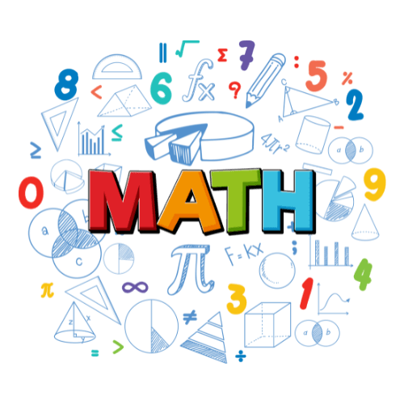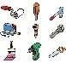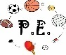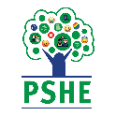

**Phonics**

 In phonics we will be completing a variety of activities depending on group. In Purple group we will be continuing on with our phonics bucket with a focus on set 1 sounds. In Green and Blue group we will continue to focus on our set 2 and 3 sounds with a focus on segmenting and blending words to aid in our reading development. All groups will practice our letter formation.

**Personal, social and emotional development**

We are continually challenging the children to develop their personal, social and emotional skills throughout each day. The staff in Elm think that this is a vital part of their development. Each child has access to the zones of regulation in each room within the unit, this allows the children to put names to their emotions and ask for help from the adults when needed. At both snack and lunch time, the children are encouraged to use their PECS or TalkPads to request items and to ask for help with cutting food or opening packets. All other children have access to a core board where they can request items they would like to eat for snack from our cupboards. The children are also encouraged daily to become more independent with their toileting and changing for PE and that independence is celebrated, even if that means they go home with their socks or jumpers inside out or the wrong way round!

**Maths**

In maths, we will be doing a variety of activities depending on ability. Some of us will be looking at ordering number forwards and backwards 1 - 20. We will continue to work on knowing what each number means and securing our knowledge to show amounts for each number using a variety of real-world resources.

Meanwhile, other children will be looking at exploring and building with shapes and objects. This will aim to develop exploration of simple shape, space and measure. Children will be given many opportunities to explore shapes and objects as well as manoeuvring themselves into spaces and around each other.

Everyone will continue to practice writing number formations.

**Expressive arts and design**

We are always creating masterpieces in Elm. Children are always given opportunities to draw, colour or paint in continuous provision. Once a week on Monday we have a dedicated Art session. This term we will be crafting lots of summer themed arts and crafts. We will also be designing and making flowers to go inside our school’s Suffolk Show Gardening competition box.

**Physical development**

 In our PE sessions we will be focusing on ways to move. We are going practice our running, jumping and skipping as well as balancing on a variety of different resources. We will also be continuing to develop our throwing and catching skills which we focused on last term, this will be achieved through adult-led games and activities displayed in the hall during our PE sessions.

**HOUSE KEEPING**

* A reminder that we do PE on a Monday and a Wednesday.
* We will use Dojo regularly to update you with photographs about what the children have been up to, please do engage with these posts and help us celebrate your children’s successes – we love hearing your feedback.
* If there are concern or queries, please do not hesitate to contact myself through the school office or arrange to book a time to meet with me. I am also available at the beginning and end of each day.