**Welcome to summer term’s learning for Elder class.**

This tells you what your child will be learning this term in school. We really value your support and the help that you can give your child with their learning. If you would like a detailed overview of curriculum coverage, please see our website [Felix Primary School](https://www.felixprimaryschool.org/)

Free Book Clipart, Transparent Book Images and Book png Files

**English**

In writing we will be writing stories. The texts that we will be using is: The Owl who was afraid of the dark, Stardust and Milo imagines the world.

In reading we will be continuing to work on our retrieval and inference skills when answering questions about a variety if texts. We will also be focusing on fluency in our reading.

Science Clipart Transparent Pictures – Clipartix

**Music**

In our music lessons we will be learning more about how music is structured and what pitch means in musical terms.

**Science**

In science, we will be learning about plants, what it means to ‘grow up’ and all about wildlife.

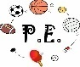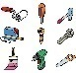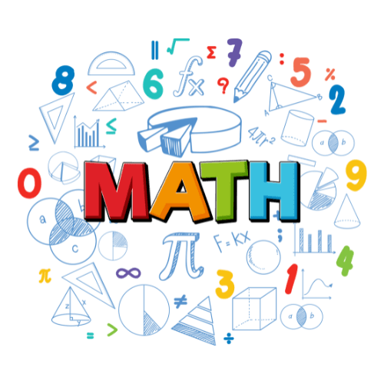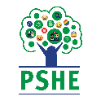Image result for clipart geography

**Phonics**

In our phonics sessions, we will be continuing to revise and learn new sounds. We will be practising using our decoding and blending skills in all reading tasks.

**Art / DT**

In art we will be using sticks to create a sculpture - these will be marine based.

**PE**

Our PE lessons this term will involve striking/fielding games and we will be working on our sending and receiving skills alongside this. After half term, we will move onto athletics and net games.

**Computing**

In computing we will be learning how to use technology to create media files such as digital music. We will also be learning more about programming by creating our own quizzes.

**Geography / History**

Our history learning will take us on a journey to discover more about people who have made a difference.

In geography, we will be learning all about life in Kenya.

**PHSE**

In our PSHE lessons, we will be learning about relationships before half term and our unit of work after half term is called ‘Changing me’. In the latter unit we will be learning about life cycles in nature, growing from young to old, boys and girls bodies, assertiveness and looking ahead.

**RE**

Our RE learning will focus on Christianity and Judaism. We will be learning about how Christians believe we should be kind to everybody and looking specifically about their belief in Jesus as God’s son and the example he sets for them.

In our Judaism topic we will be focusing on ‘Who is God to the Jews?’

**Maths**

In maths, we will be learning about fractions and time in the first half term and then statistics and position after the May half term break.

**HOUSE KEEPING**

* A reminder that we do PE on a Tuesday and a Friday. The expectation is that your child has their PE kit in school every day.
* We do try to hear children read at least once every two weeks so please ensure your child has their school reading book in school every day.
* As the weather gets warmer, it is essential that your child brings a named water bottle into school.
* Children will be awarded dojo points for showing resilience and kindness. They will also be awarded dojo for any special achievements they make in their learning.
* If you have any concerns or queries, please do not hesitate to contact us through the school office or arrange to book a time to meet with us via dojo messaging. We are also available at the beginning and end of every day.