**Welcome to summer term’s learning for Cherry class.**

This tells you what your child will be learning this term in school. We really value your support and the help that you can give your child with their learning. If you would like a detailed overview of curriculum coverage, please see our website [Felix Primary School](https://www.felixprimaryschool.org/)

Free Book Clipart, Transparent Book Images and Book png Files

**English**

In writing we will be writing narratives and explanation texts. We will be using ‘The Happy Prince, The last Bear and The Magic Paintbrush to inspire us and support us with our writing. In our English lessons we are having a particular focus on handwriting and taking pride in our learning, we are ensuring this is continued throughout all our subjects.

In reading we will be continuing with our focus on fluency and retrieval through the use of The Firework Maker’s Daughter. The children will spend time reading and answering a range of questions about the text.

Science Clipart Transparent Pictures – Clipartix

**Music**

Our music lessons will see us explore Jazz and Ballads. The children enjoy the creativity and the freedom our music sessions give them to express themselves creatively while developing their understanding of a range of music.

**Science**

In science, we will be developing our scientific knowledge of plants, force, magnets and biodiversity. Our science lessons will also give us the opportunity to develop our skills as scientific thinkers.

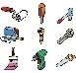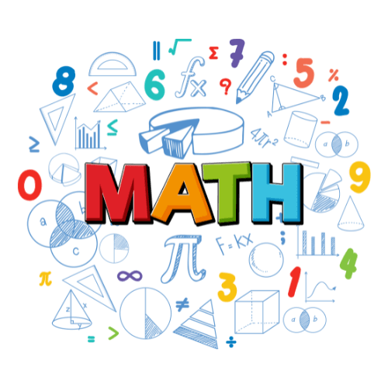Image result for clipart geography

**Languages**

The children are learning French and the topics they are learning about are ‘La Famille’ which is ‘the family and ‘Bon Anniversaire’ which is ‘happy birthday’. The children enjoy their French lessons and having the opportunity to use the new words and phrases they have learnt in conversations with each other.

**Art / DT**

In Art the children are looking at animated drawings and developing the skills required make their own pictures with moving parts. DT will see the children learn about textiles and will allow the children to build on their sewing skills that were used earlier in the year.

**PE**

In PE with Mr Entwistle the children will be covering a range of sports including, athletics, tennis and cricket. Children do need to have a full PE kit in school to ensure they are able to participate in PE lessons every week.

**Computing**

In computing the children are learning about ‘desktop publishing’ and ‘events and actions’. The children have regular opportunities to use the chromebooks in school to put their knowledge into practice and develop the skills they have learnt about in the lesson.

**Geography / History**

In History we are going back to explore more about Ancient Egypt. The children had lots of fun learning about this topic earlier in the year and are keen to find out more about this period of time. In Geography we will be learning about Europe and developing our knowledge of the continent.

**PHSE**

In PSHE we will also be using the Jigsaw lessons to support the children’s learning around Relationships and the topic ‘changing me’. The children will have time to reflect, discuss and ask any questions they may have throughout any of these lessons.

**RE**

In RE we will be using our new Jigsaw lessons to support the children’s learning around Christianity and Sikhism. The lessons allow for a lot of time for discussion and reflection to ensure children have a good understanding of the topics they are learning about.

**Maths**

In maths, we will be covering a wide range of topics including, fractions, money, time, shape and statistics. Time and money are great topics you can explore at home in real life situations with your children to support their understanding of these. As well as covering these topics in maths, the children have lots of exposure to times tables, which we encourage your children to do at home through Times table Rockstars. We also spend time each week embedding our problem solving and reasoning skills as well as our arithmetic skills using the four basic functions of addition, subtraction, multiplication and division.

**HOUSE KEEPING**

* A reminder that we do PE on a Monday and Thursday the expectation is that your child has their PE kit in school for these days.
* Dojos are given when displaying and following the school rules and values. Please continue to check Dojo for regular class updates and to keep track on their points.
* If there are concern or queries please do not hesitate to contact myself through the school office, or arrange to book a time to meet with me. I am also available at the beginning and end of every day.