PE Funding

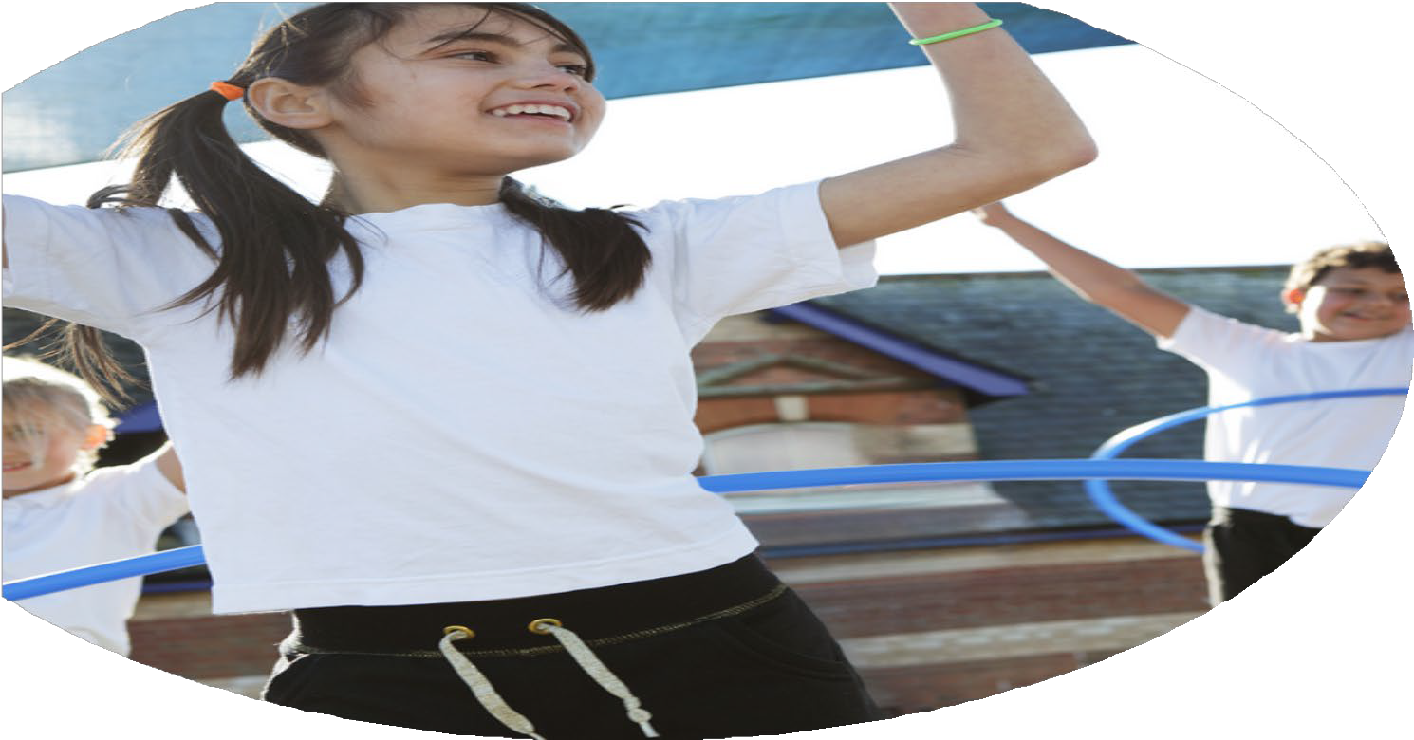

Evaluation Form

**Commissioned by**

**Created by**

Images courtesy of Youth Sport Trust

**PE Funding Evaluation Form**

 It is intended that this template should be used as preparation for the completion of the statutory digital reporting tool being introduced this academic year. You can upload data (including swimming) from this template onto this platform once it becomes accessible.

 Before you decide how you are going to use the funding for this academic year you should reflect and evaluate the impact of your use of the funding in 2023/24.

 All spending of the funding must conform with the terms outlined in the Conditions of Grant document.  The template is a working document that you can amend/update during the year.

 Based on your evaluation of last year’s funding you should decide what you intend to do this academic year, how you will do it, and what impact you expect it to have.

It is important that the funding is used effectively and based on your school’s needs.

 You must use the funding to make additional and sustainable improvements to the PE and sport in your school.  You must develop and add to the PESSPA activities that your school already offers.

*Summative digital reporting from June 2025 will continue to include swimming and water safety information therefore funding can be used to provide top-up lessons where necessary to ensure pupils meet national curriculum swimming requirements.*

**We recommend that you start by reflecting on the impact of current provision and reviewing your previous spend**

|  |  |  |  |
| --- | --- | --- | --- |
| What went well? | How do you know? | What didn’t go well? | How do you know? |
| **GetSet4PE Subscription**  **Continued to access to schools competitions (Schools games membership and competitions in the local Felixstowe area/staff cover/transport).**  **Provision of extra-curricular clubs.**  **Investment in Moki fitness trackers** | Teacher feedback is that the scheme of work is easy to follow with great tools to help them plan and deliver their lessons and assess  Pupils are given the opportunity to represent our school in a variety of competitive and non-competitive events, positive feedback from pupils  Good numbers of children attending  Children are extremely positive about being able to use them. | **The assessment section needs updating as the children move up into different classes and year groups.**  **Staffing when PE lead couldn’t attend Time it takes to fill out risk assessments for these events.**  **Only a minority of children at school attend extra-curricular sports clubs.**  **Setting up process is time consuming.** | Children in previous year group on website  Disruption caused taking adults from classes.  Mostly same children attending  Each teacher needs to have the app installed on their computer and a login created and then shown how the trackers work. |

|  |  |
| --- | --- |
| What are your plans for 2024/25? | How are you going to action and achieve these plans? |
| Intent | Implementation |
| **Provision for extra-curricular sports clubs. Encourage different children**  **Continue to access to schools’ competitions (Schools games membership and competitions in the local Felixstowe area/staff cover/transport).**  **Continued subscription to GetSet4PE.**  **Invest in repairs to current sports equipment and apparatus along with investing in new equipment.**  **Arrangement of whole school enrichment events inside or outside of school.** | Currently we help subsidise extra-curricular sports clubs. Summer term, offer extra-curricular sports clubs to pupils for free using funding.  PE lead will now be able to drive the minibus - fewer restrictions an the events we will be able to attend. Found supply TA who is happy to attend events  This continues to be a great and easy to follow scheme of work for all staff. It also offers great assessment tools to aid tracking pupil progress.  List of required improvements  List of equipment to be purchased  Summer term plan for whole school to attend an enrichment day at Pipers Vale gymnastics center. |

|  |  |
| --- | --- |
| What impact/intended impact/sustainability are you  expecting? | How will you know? What **evidence** do you have or  expect to have? |
| Impact of free sports club in summer term - encourage those who don’t usually or are unable to attend.  Impact of parents seeing enjoyment – sustain attendance.  Impact of events outside school - interact with other pupils from other schools, encourage competitiveness, experience belonging and help them to understand what it means to be a part of a team.  Sustainability – ‘schools games’ offer regular events  Impact – GetSet4PE – staff confidence and delivery of well structured curriculum with accurate assessment tools  Impact – improvement of equipment which needs updating  Impact of sporting enrichment activities – new experiences and opportunities. | Club registers  Pupil voice  ‘Schools games’ registers  Our registers  Pupil and parent voice  Teacher feedback  Pupil voice  Lesson monitoring  Assessment – attainment and progress  Better use of equipment  Better variety  Pupil voice and take up |

|  |  |
| --- | --- |
| What **impact/sustainability** have you seen? | What **evidence** do you have? |
| Since Sep 24, 10 sports events attended  All ages  SEND  To continue | Registers  Photographs |